1.  
> CreditHours <- c(5,3,3,3,3)

> Difficulty <- c(7,5,6,4,3)

> Workload <- c(10,6,7,5,4)

> df = data.frame(CreditHours,Difficulty,Workload)

names = c("Japanese","Trig","CS Principles","CS STATS","INOV")

rownames(df) = names

> df

CreditHours Difficulty Workload

Japanese 5 7 10

Trig 3 5 6

CS Principles 3 6 7

CS STATS 3 4 5

INOV 3 3 4

2A.  
newdf1 = subset(starwars,mass >= 100)

newdf2 = subset(starwars,eye_color == "blue")

newdfactual = merge(newdf1, newdf2, by="name")

View(newdfactual)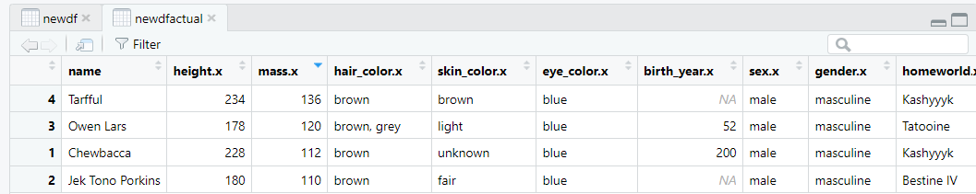  
2B.  
> humanData = subset(starwars,species == "Human")

> nonhumanData = subset(starwars,species != "Human")

df <- data.frame("Height" = c(mean(humanData$height,na.rm=TRUE), mean(nonhumanData$height,na.rm=TRUE)),"Mass" = c(mean(humanData$mass,na.rm=TRUE), mean(nonhumanData$mass,na.rm=TRUE)))

rownames(df) = c("Height","Mass")

columnnames(df) = c("Human","Nonhuman")

> df

Human Nonhuman

Height 176.6452 82.78182

Mass 172.4043 107.56111

2C.  
df = subset(starwars, grepl("Revenge of the Sith", starwars$films))

> df

# A tibble: 34 × 14

name height mass hair_color skin_…¹ eye_c…² birth…³ sex gender homew…⁴ species films vehic…⁵ stars…⁶

*<chr>* *<int>* *<dbl>* *<chr>* *<chr>* *<chr>* *<dbl>* *<chr>* *<chr>* *<chr>* *<chr>* *<lis>* *<list>* *<list>*

1 Luke Skywalker 172 77 blond fair blue 19 male mascu… Tatooi… Human <chr> <chr> <chr>

2 C-3PO 167 75 NA gold yellow 112 none mascu… Tatooi… Droid <chr> <chr> <chr>

3 R2-D2 96 32 NA white,… red 33 none mascu… Naboo Droid <chr> <chr> <chr>

4 Darth Vader 202 136 none white yellow 41.9 male mascu… Tatooi… Human <chr> <chr> <chr>

5 Leia Organa 150 49 brown light brown 19 fema… femin… Aldera… Human <chr> <chr> <chr>

6 Owen Lars 178 120 brown, gr… light blue 52 male mascu… Tatooi… Human <chr> <chr> <chr>

7 Beru Whitesun lars 165 75 brown light blue 47 fema… femin… Tatooi… Human <chr> <chr> <chr>

8 Obi-Wan Kenobi 182 77 auburn, w… fair blue-g… 57 male mascu… Stewjon Human <chr> <chr> <chr>

9 Anakin Skywalker 188 84 blond fair blue 41.9 male mascu… Tatooi… Human <chr> <chr> <chr>

10 Wilhuff Tarkin 180 NA auburn, g… fair blue 64 male mascu… Eriadu Human <chr> <chr> <chr>

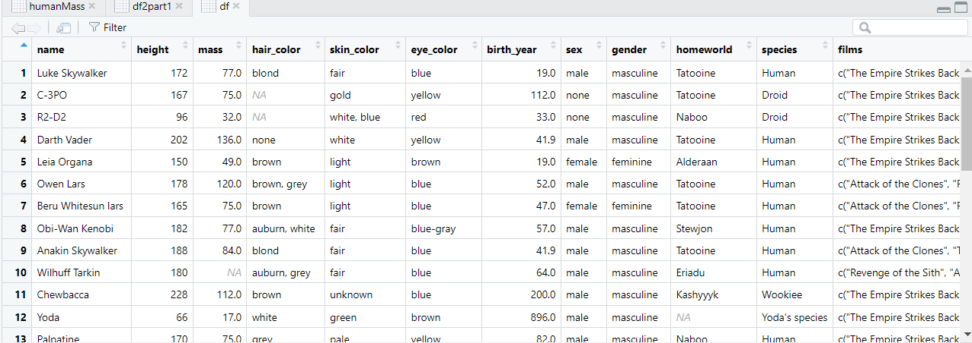

2D.

x = c(sum(is.na(starwars$name)) /length((starwars$name)),sum(is.na(starwars$height)) /length((starwars$height)),sum(is.na(starwars$hair_color)) /length((starwars$hair_color)),sum(is.na(starwars$skin_color)) /length((starwars$skin_color)),sum(is.na(starwars$eye_color)) /length((starwars$eye_color)),sum(is.na(starwars$birth_year)) /length((starwars$birth_year)),

+ + sum(is.na(starwars$sex)) /length((starwars$sex)),sum(is.na(starwars$gender)) /length((starwars$gender)),sum(is.na(starwars$homeworld)) /length((starwars$homeworld)),sum(is.na(starwars$species)) /length((starwars$species)),sum(is.na(starwars$films)) /length((starwars$films)),sum(is.na(starwars$vehicles)) /length((starwars$vehicles)),sum(is.na(starwars$starships)) /length((starwars$starships)))

> x

x

[1] 0.00000000 0.06896552 0.05747126 0.00000000 0.00000000 0.50574713 0.04597701 0.04597701 0.11494253 0.04597701

[11] 0.00000000 0.00000000 0.00000000

3A.

> x <- sample(c(1,3,5,7,11,13), size = 50, replace = TRUE)

> x

[1] 1 3 7 5 5 5 7 3 5 11 11 5 7 13 11 11 5 11 11 3 13 11 3 13 3 11 7 5 3 3 5 13 11 13 5 1 1 1

[39] 1 7 11 13 5 3 1 7 5 3 1 1

3B.  
for (k in 1:100) {

+ x <- rpois(n=(k*100), lambda = 2)

+ print(mean(x))

+ }

[1] 2.04

[1] 1.895

[1] 1.87

[1] 1.9725

[1] 2.126

[1] 2.053333

[1] 1.991429

[1] 1.98875

[1] 1.99

[1] 2.032

[1] 1.938182

[1] 2.048333

[1] 2.040769

[1] 1.971429

[1] 2.054667

[1] 1.959375

[1] 1.982941

[1] 2.013333

[1] 1.928421

[1] 1.9865

[1] 1.971429

[1] 2.017727

[1] 1.93087

[1] 2.029583

[1] 1.9864

[1] 2.044231

[1] 1.976667

[1] 1.963214

[1] 1.995172

[1] 1.971667

[1] 1.992581

[1] 2.025625

[1] 2.037273

[1] 2.021176

[1] 1.992857

[1] 2.032222

[1] 1.97027

[1] 2.001579

[1] 2.023333

[1] 1.99325

[1] 2.009756

[1] 1.98619

[1] 2.005349

[1] 1.997955

[1] 2.000222

[1] 2.030217

[1] 1.969574

[1] 2.014792

[1] 1.992857

[1] 1.989

[1] 2.012157

[1] 1.989808

[1] 1.98283

[1] 1.990185

[1] 1.976

[1] 1.966964

[1] 1.987018

[1] 2.020517

[1] 2.008136

[1] 2.0065

[1] 1.995246

[1] 1.998387

[1] 2.011587

[1] 1.9925

[1] 2.010462

[1] 1.990758

[1] 1.992836

[1] 2.007794

[1] 1.984348

[1] 2.001286

[1] 1.983239

[1] 1.986528

[1] 2.000548

[1] 2.006081

[1] 1.985333

[1] 1.999474

[1] 1.993117

[1] 1.990641

[1] 2.018608

[1] 2.03225

[1] 2.021975

[1] 2.003049

[1] 2.012651

[1] 2.02119

[1] 1.996235

[1] 1.98593

[1] 2.005172

[1] 2.004545

[1] 2.003483

[1] 1.985

[1] 1.997912

[1] 1.9975

[1] 1.983548

[1] 1.993617

[1] 2.017789

[1] 2.005625

[1] 1.998866

[1] 2.016633

[1] 2.011919

[1] 1.9988

Mean seems to be approaching the lambda value which is 2.